*Infrastructure for BMW Test Car Display System*

**GUI DESCRIPTION**

**DOCUMENT**

TABLE OF CONTENTS

Flow Chart 3

Sketch 4

Main Menu 5

* Live Conditions 6
* Log vi
* About vii
* Help vii

Extras vii

# Flow Chart

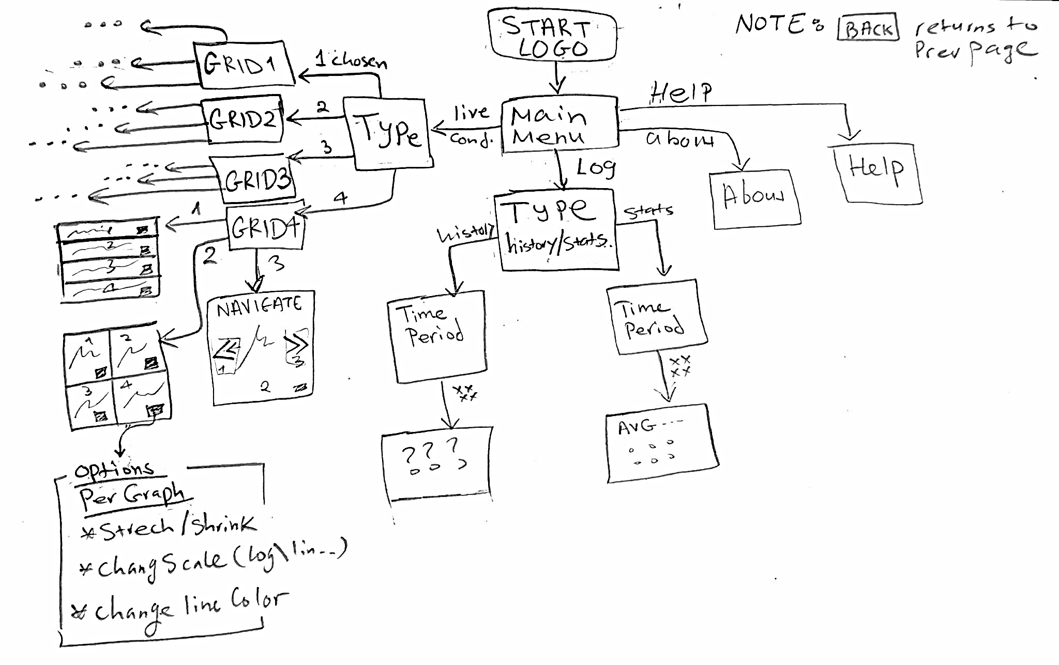

# Sketch

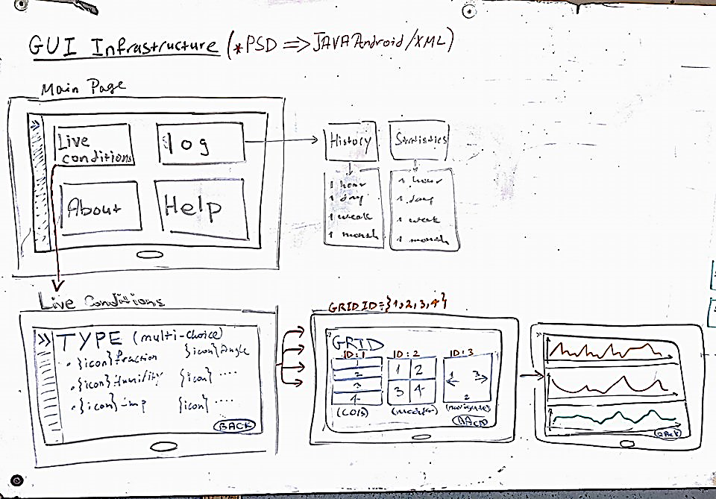

# Main Menu

Components:

* Live Condition **Button**
* Log **Button**
* About **Button**
* Help **Button**
* Options **Side Bar**

# Live Condition



Grid layout to view the data

Users choose type of condition to view (up to 4 selections)